

Final Project

**Report on ICT and related technologies**

Computer Engineering

2023-2024

|  |  |
| --- | --- |
| Authors : | Email : |
| Belkaim Mohamed Mehdi | 232331432718 |
| Ziane Fatima Zohra | 232337422719 |
| Bouchefra Yacine | 232331388118 |
| Abdelmalek Zouaoui | 232332138706 |
| Mouhouche Wassim | 232331531509 |

30th December 2023

Contents

1. Introduction 3

2. Historical Evolution Of ICT 3

3. Core Components Of ICT 4

4. Emerging Trends In ICT (Artificial Intelligence And Machine Learning) 5

4.1. Overview Of AI And Ml Technology 5

4.2. Chatbots And Virtual Assistants 5

5. Cybersecurity In ICT 6

6. Key Technologies Related To ICT 7

6.1. Networking Technologies 7

6.2. Internet Of Things (IOT) 7

6.3. Communication Technologies 7

6.4. Software Development Technologies 7

6.5. Google Services And Tools 8

6.6. Microsoft Tools And Technologies 8

7. Case Study: A Look At How Tesla Utilizes Ict For Success 9

8. The Conclusion 10

# 1. Introduction

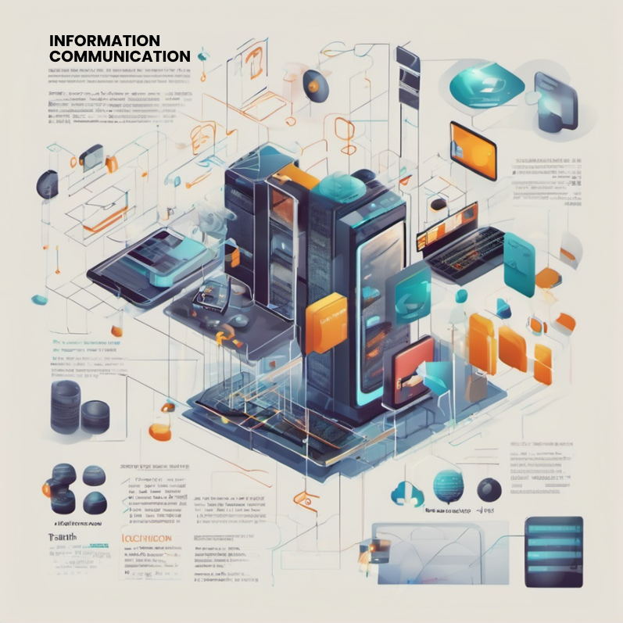In today's interconnected era, Information and Communication Technologies (ICT) stands as the cornerstone of our digital landscape. ICT[1], encompassing diverse technologies facilitating the collection, processing, and transmission of information, holds paramount importance in the fabric of modern society. This report aims to unravel the intricacies of ICT and illuminate the transformative power of ICT, serving as a guide to understanding its multifaceted role in shaping our contemporary world. The overarching purpose is to provide a comprehensive overview, fostering awareness and promoting a deeper understanding of the significance that ICT holds in our evolving technological sphere.

# 2. Historical Evolution Of ICT

**T**he historical evolution of Information and Communication Technologies (ICT) is a complex journey shaped by significant milestones and key developments. It began with the invention of the telegraph, enabling rapid long-distance communication. Alexander Graham Bell's telephone further revolutionized interpersonal communication, while the mid-20th century saw the pivotal advent of computers, marking a transformative moment in ICT. **T**he subsequent development of the Internet accelerated global interconnectedness, fostering communication and collaboration. The proliferation of mobile technologies led to smartphones and widespread wireless communication adoption.

**T**hese technological advancements profoundly impacted information dissemination, ushering in a transition from traditional print media to digital formats facilitated by the Internet. This shift transformed how information is created, shared, and consumed. Social media platforms emerged as powerful tools for real-time communication, democratizing access to news and diverse perspectives. Online publishing and multimedia content further diversified information sources and formats. **H**owever, this evolution raised concerns about information reliability and integrity, as misinformation and fake news can rapidly spread in the digital age.

**T**he historical evolution of ICT, from the telegraph to the Internet and beyond, has redefined global communication and information dissemination. While positively impacting connectivity and information sharing, challenges such as information integrity and digital divides underscore the ongoing need for scrutiny and responsible technology use.

Telephone (voice)

Radio

Closed

Circuit

Television

Hi-speed

Wireless

Telegraph

Satellite

E-mail

Internet

1900

1920

1940

1960

1980

2000

# 3. Core Components Of ICT

**T**he core components of Information and Communication Technologies (ICT) encompass hardware, software, and networks, each playing a crucial role in the functioning of technological systems. **H**ardware refers to the physical devices and infrastructure that form the backbone of ICT. This includes computers, servers, routers, and other tangible equipment necessary for processing and transmitting data.

**S**oftware, on the other hand, constitutes the applications and programs that enable users to perform specific tasks. These range from operating systems and productivity software to specialized applications tailored for diverse purposes. The significance of software lies in its ability to enhance functionality, automate processes, and facilitate user interactions.

**N**etworks are fundamental to ICT, providing the infrastructure for communication and data exchange. Understanding communication networks involves grasping the intricacies of how devices are interconnected, be it through LANs[2],WANs[3], or the global Internet.

**4.** Emerging Trends in ICT (Artificial Intelligence and Machine Learning)

## 4.1. Overview Of AI And Ml Technology

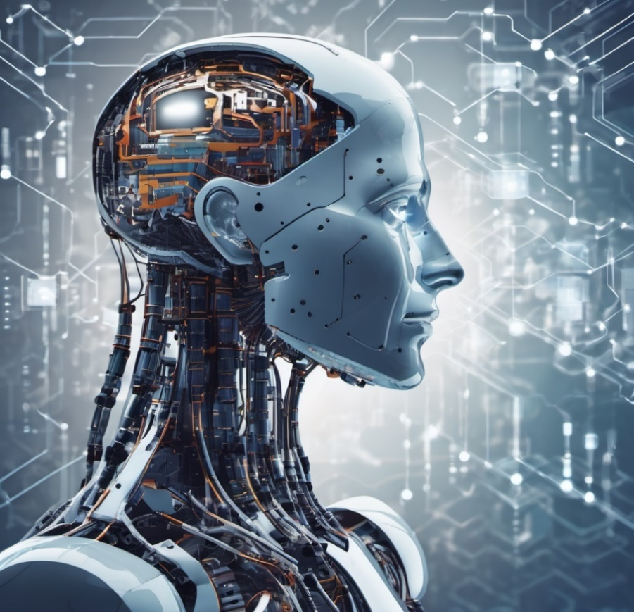**A**I[4] and ML[5] have become increasingly important in various industries, enhancing efficiency, accuracy, and reliability in ICT processes. They analyze historical data to predict product defects, optimize test cases, diagnose diseases, and aid in fraud detection and risk assessment. AI-driven technologies also enable real-time monitoring, minimizing risks and improving operational efficiency. **H**owever, the implementation of AI and ML faces challenges such as data privacy concerns, ethical considerations, and the need for massive datasets for effective machine learning. **T**he need for interpretability in complex AI models and fairness in algorithms is also a critical concern. The initial investment required for implementing these technologies may be substantial, and organizations must overcome resistance to change and invest in employee training. **T**he rapid evolution of AI and ML necessitates ongoing updates and maintenance, further posing challenges for ICT businesses.

## 4.2. Chatbots And Virtual Assistants

**C**hatbots and Virtual Assistants simplify interactions with users. Rule-based chatbots follow predefined rules, while AI-driven ones use natural language processing and machine learning for dynamic responses, Virtual Assistants like Alexa and Siri use voice recognition and AI to perform tasks.

**I**mplementing chatbots in customer support speeds up responses, providing instant help for common queries. This allows human agents to focus on more complex issues. Virtual Assistants efficiently handle appointment scheduling, reducing administrative workload and minimizing errors. Chatbots retrieve information about standards and regulations, ensuring quick and accurate responses. **V**irtual Assistants contribute to automation by managing tasks like document verification and data entry. Overall, these technologies enhance user experiences and streamline various processes.

# 5. Cybersecurity In ICT

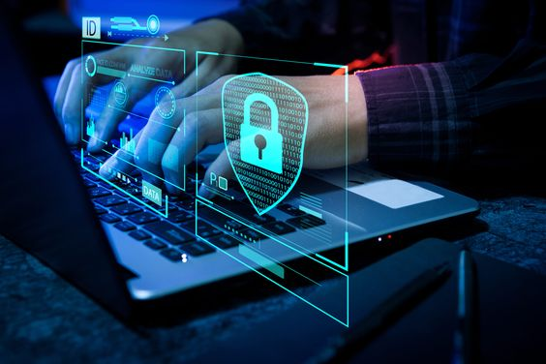Keeping information and communication technologies (ICT) safe from online threats is important. There are many dangers like viruses, ransom attacks, fake emails, and tricks to get personal information. These threats can harm data and communication networks. Because our devices and technologies are all connected, there are more chances for attacks. Cybersecurity helps keep important information safe, making sure it stays private, reliable, and available. It also protects against problems like losing money or a good reputation.

To do this well, it's important to use good tools like strong firewalls and antivirus programs and to regularly update software. Encrypting data, teaching employees about online threats, controlling access to information, and having plans for when something goes wrong are also part of the best ways to stay safe online.

# 

# 6. Key Technologies Related To ICT

## 6.1. Networking Technologies

* 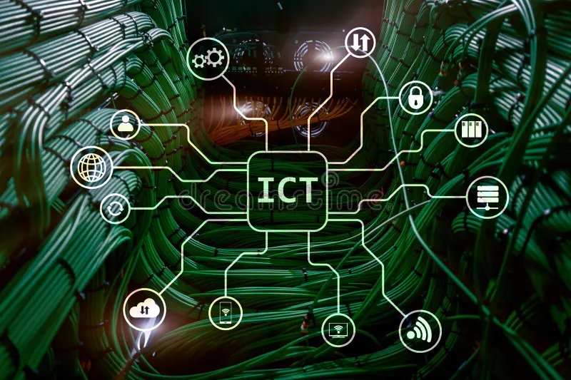**Internet Protocol (IP):** The foundation of Internet communication, IP enables the routing of data packets across networks.
* **Ethernet and Wi-Fi:** Common technologies for local and wireless network connectivity.
* **Network Protocols (TCP/IP, HTTP, DNS):** Protocols that govern data transmission and communication on the internet.

## 6.2. **Internet Of Things (IOT)**

* **Sensors and Actuators :** Devices that collect data from the physical world and can perform actions based on that data.
* **IoT Platforms:** Enable the management, analysis, and integration of data from IoT devices.

## 6.3. Communication Technologies

* **Voice over IP (VoIP):**Allows voice communication over the internet, facilitating cost-effective and efficient telephony.
* **Unified Communications (UC) :**Integrates various communication tools (voice, video, messaging) into a unified platform.

## 6.4. Software Development Technologies

* **Integrated Development Environments (IDEs):** Software tools for coding, testing, and debugging applications.
* **Version Control Systems (e.g., Git, TFVC, Mercurial, Perforce):** Manages changes to source code and facilitates collaboration in software development. The most popular version control system is Git, it allows multiple developers to work on a project simultaneously, and it provides features like branching and merging, making it highly versatile. GitHub, GitLab, and Bitbucket are popular hosting services that support Git.

## 6.5. Google Services and Tools

|  |  |
| --- | --- |
| **Search Engine Optimization (SEO) with Google**  Search Engine Optimization SEO is a crucial strategy for improving online visibility, particularly on Google . It involves creating content that aligns with Google's search algorithms, using relevant keywords, and implementing best practices to improve search results. SEO's significance lies in driving organic traffic, increasing online visibility, and establishing a strong online presence.  **Google Analytics**  Google Analytics is a comprehensive web analytics service that tracks and analyzes website traffic, user behavior, and performance, providing data-driven decision-making and optimizing online presence for businesses.  **Google Drive**  A cloud storage service for storing and sharing files, enabling collaboration. | **Gmail and Google Workspace**  Gmail and Google Workspace offer a unified communication and productivity solution, enhancing efficiency and collaboration through seamless integration of email management features.  **Google Docs, Sheets, and Slides:**  office suite for word processing spreadsheet creation, and presentation development, respectively.  **Google Ads and Monetization** Google Ads is a paid-per-click platform for businesses, enabling targeted ads and monetization through the AdSense program, allowing publishers to earn revenue through clicks or impressions. |

## 



## 6.6. Microsoft Tools And Technologies

**Microsoft Office Suite**

**T**he Microsoft Office Suite is a comprehensive collection of productivity applications, such as Word, Excel, and PowerPoint. It is widely utilized for tasks like document creation, data analysis, and presentation development.

|  |  |
| --- | --- |
| **Microsoft Teams and Collaboration**  Microsoft Teams is a flexible collaboration platform that provides chat, video conferencing, file sharing, and productivity tools. Its integration with Microsoft Office applications streamlines efficiency and document sharing. In comparison to alternatives like Slack and Zoom, Teams offers a unified experience across diverse productivity applications, making it particularly beneficial for businesses. | **Microsoft Azure Cloud Computing**  Microsoft Azure is a powerful cloud-based application that simplifies application creation, deployment, and management. It integrates seamlessly with other Microsoft products like Windows Server, has global data centers, and adheres to strict rules. As a reliable, feature-rich cloud solution, Azure is an excellent choice for businesses. |

# 7. Case Study: A Look at How Tesla Utilizes ICT For Success

In this case study, we examine the strategic implementation of Information and Communication Technologies (ICT) by Tesla, Inc. showcasing how the company harnesses cutting-edge technologies to drive success in the automotive and clean energy industry.

**ICT Integration:**

Tesla, founded by Elon Musk, is a global leader in the automotive sector, renowned for its innovative, sustainable, and advanced technologies, including electric vehicles and energy storage.

Tesla's success is intricately tied to its adept use of ICT. The company utilizes a sophisticated network of interconnected systems for manufacturing, supply chain management, and vehicle design. Through the integration of cloud computing, data analytics, and Internet of Things (IoT) devices, Tesla has optimized production processes, ensuring efficiency, quality, and responsiveness to market demands.

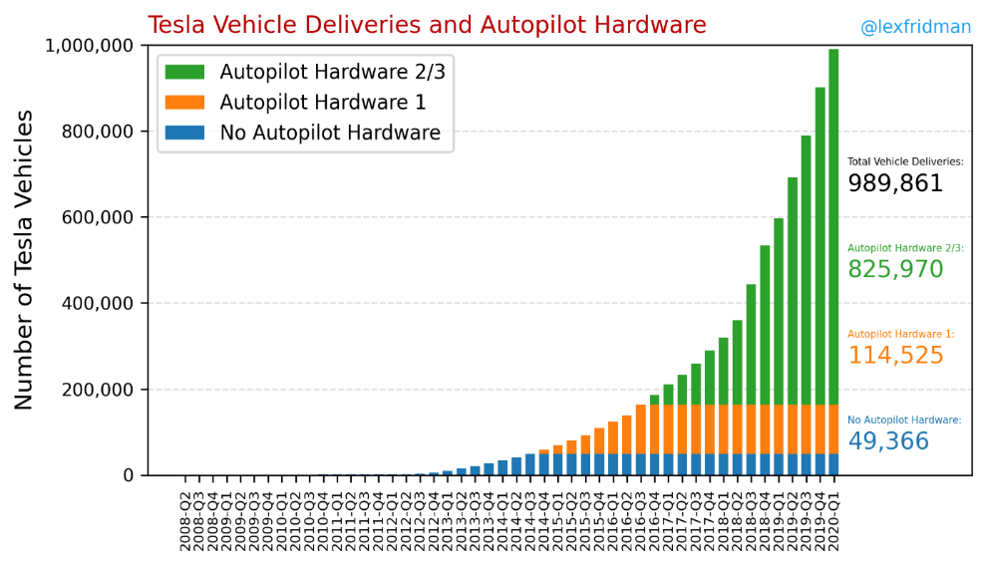**Vehicle Connectivity & Supply Chain Optimization:**

**T**esla leverages ICT to optimize both its supply chain and vehicle performance. The company uses real-time data and analytics to improve visibility, predict demand, and manage inventory efficiently in the supply chain. **S**imultaneously, Tesla gathers and analyzes data from its extensive network of operational vehicles for predictive maintenance, reducing downtime and enhancing customer satisfaction. **I**n the realm of vehicle connectivity, Tesla employs advanced software and over-the-air updates for seamless integration. This approach enhances features, addresses issues, and introduces new functionalities, ultimately contributing to an improved user experience and ongoing enhancements in performance and safety.

**Energy Solutions &** **Challenges Faced:**

**I**n addition to electric vehicles, Tesla's foray into clean energy solutions involves the use of ICT in its solar products and energy storage systems. Smart grid technologies and digital monitoring enable efficient energy production, storage, and distribution.

**T**esla's venture into clean energy solutions incorporates ICT in its solar products and energy storage systems. The application of smart grid technologies and digital monitoring facilitates efficient energy production, storage, and distribution. **D**espite its success, Tesla encounters challenges in ICT implementation, such as software glitches, cybersecurity concerns, and the management of massive data generated by connected vehicles and energy products.

**Result:**

**T**esla's case exemplifies the transformative impact of ICT on a company's operations, innovation, and market leadership. By strategically integrating advanced technologies, Tesla has not only revolutionized the automotive industry but has also set new standards for sustainability and efficiency. **T**his case study underscores the pivotal role that ICT plays in shaping Tesla's success story and serves as a testament to the potential of technology in driving positive change within industries.

# 8. The Conclusion

In contemplating the future of Information and Communication Technologies (ICT), the outlook is one of unprecedented growth and innovation, anticipating a surge in ICT adoption across industries and the integration of emerging technologies, promising a landscape of connectivity and automation. This transformative journey brings both opportunities and challenges; businesses can leverage ICT for efficiency and innovation but must navigate risks such as cybersecurity threats and ethical concerns around privacy and bias in AI. Striking a delicate balance between seizing opportunities and mitigating risks is crucial for businesses to thrive in this technologically enriched future. Proactive measures in cybersecurity, data ethics, and responsible AI use are imperative to ensure the widespread benefits of ICT across businesses and society. As we approach this future, a thoughtful and ethical approach will be key to harnessing the full potential of ICT.

Acknowledging certain limitations encountered during the study is essential. These may include the rapidly changing landscape of technology, variability in the adoption of TIC across industries, and limitations in available data for certain technologies. Understanding these limitations provides context for interpreting the findings and underscores the need for ongoing research in the field.

Given the dynamic nature of TIC, further research is recommended in areas such as advancements in AI and ML applications, evolving cybersecurity threats and countermeasures, and the integration of emerging technologies in business processes.

**References:**

[LSE - ICT References](https://www.lse.ac.uk/media-and-communications/people/visiting-and-associate-staff/leslie-haddon/ict-references) - Paper for the CRIC workshop 'Researching Time', University of Manchester, 19th September. Haddon, L. (2004) Information and Communication Technologies.

[Emerald - ICT Competences](https://www.emerald.com/insight/content/doi/10.1108/978-1-83909-550-420201006/full/pdf?title=references) - Gender and socioeconomic-related differences in performance-based ICT competences. Computers & Education, 84, 8–25. Ahmad, M., Badusah, J., Mansor, A. Z., Karim.

[Grafiati - ICT Coordinators](https://www.grafiati.com/en/literature-selections/information-and-communication-technology-ict/) - A program meeting the identified needs of ICT coordinators. The study concludes with recommendations and suggestions for further research.

[ResearchGate - ICT in Education](https://www.researchgate.net/publication/303094242_Information_and_Communications_Technologies_ICT_and_Pre-Service_Education_Professionals_A_Case_Study_of_Motivation_and_Knowledge) - Information and Communications Technologies (ICT) and Pre-Service Education Professionals: A Case Study of Motivation and Knowledge. International Journal of.

[Tallinn University - Information and Knowledge Management](https://www.tlu.ee/~sirvir/Information%20and%20Knowledge%20Management/Technologies%20for%20Information%20and%20Knowledge%20Management/references.html) - Resources for knowledge management architectures beyond technology. Capozzi, M. M. (2007).

[WikiEducator - General ICT in Education](https://wikieducator.org/General_ICT_in_Education_References) - The study was based on existing research on the global use of Assistive Technology and ICT-based resources within the Special Needs sector.

**Sources:**

* [Emerald - ICT Competences](https://www.emerald.com/insight/content/doi/10.1108/978-1-83909-550-420201006/full/pdf?title=references)
* [Grafiati - ICT Coordinators](https://www.grafiati.com/en/literature-selections/information-and-communication-technology-ict/)
* [ResearchGate - ICT in Education](https://www.researchgate.net/publication/303094242_Information_and_Communications_Technologies_ICT_and_Pre-Service_Education_Professionals_A_Case_Study_of_Motivation_and_Knowledge)
* [Tallinn University - Information and Knowledge Management](https://www.tlu.ee/~sirvir/Information%20and%20Knowledge%20Management/Technologies%20for%20Information%20and%20Knowledge%20Management/references.html)
* [WikiEducator - General ICT in Education](https://wikieducator.org/General_ICT_in_Education_References)

1. ICT : Information and Communication of Technologies
2. LANs : Local Area Networks
3. WANs : Wide Area Networks
4. AI : Artificial Intelligence
5. ML : Machine Learning